**1. Write a MongoDB query to display all the documents in the collection restaurants**

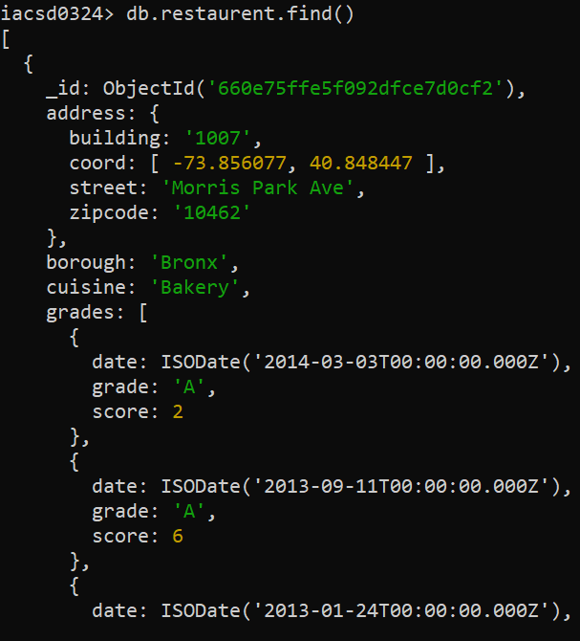

**2. Write a MongoDB query to display the fields restaurant_id, name, borough and cuisine for**

**all the documents in the collection restaurant.**

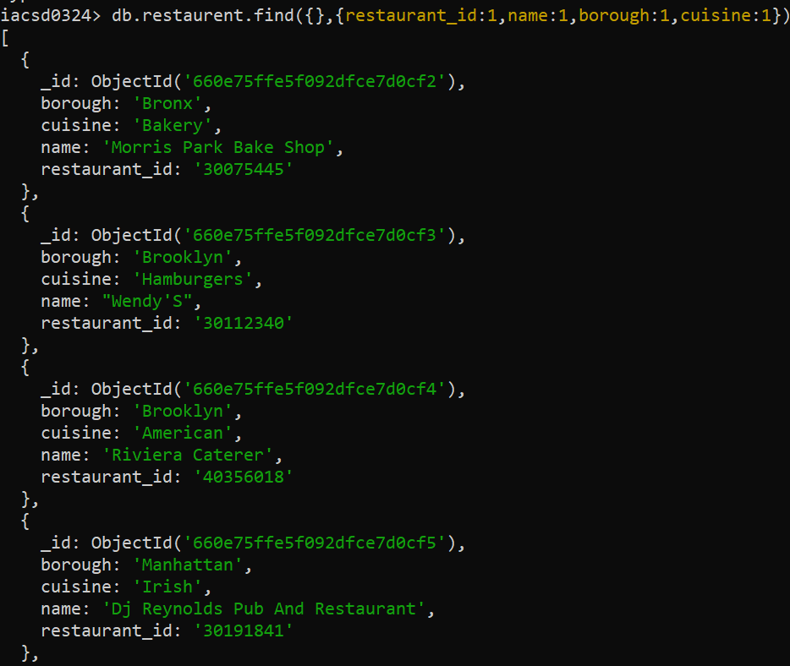

**3. Write a MongoDB query to display the fields restaurant_id, name, borough and cuisine,**

**but exclude the field _id for all the documents in the collection restaurant.**

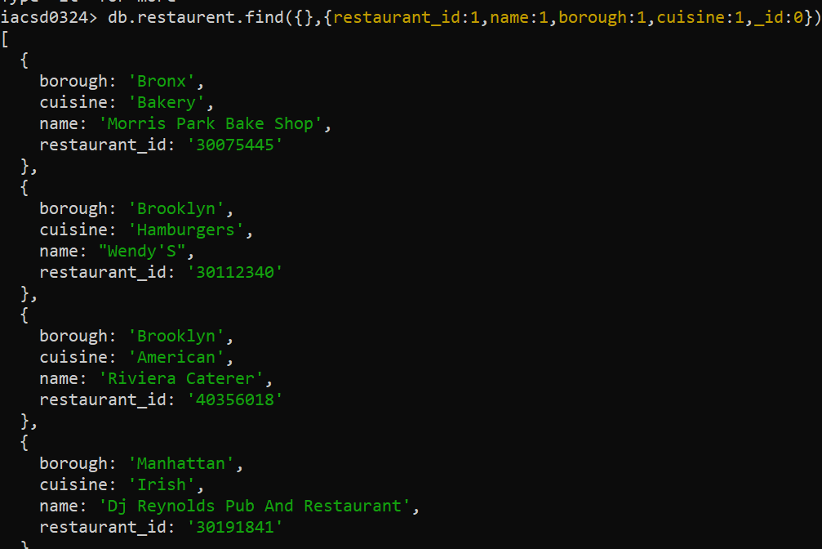

**4. Write a MongoDB query to display the fields restaurant_id, name, borough and zip code,**

**but exclude the field _id for all the documents in the collection restaurant.**

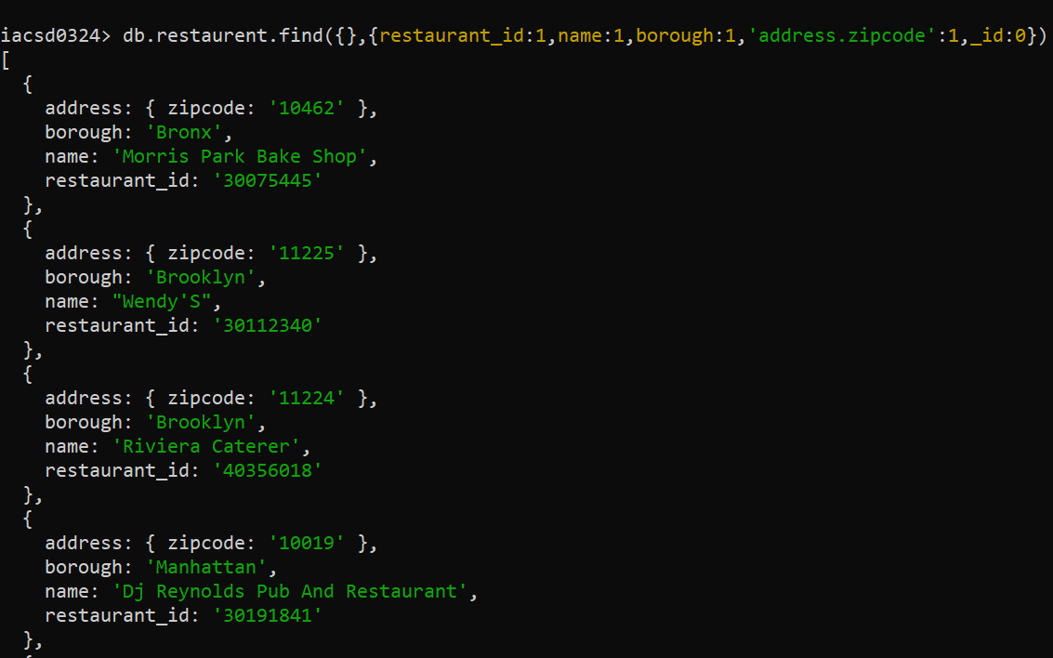

**5. Write a MongoDB query to display all the restaurant which is in the borough Bronx**

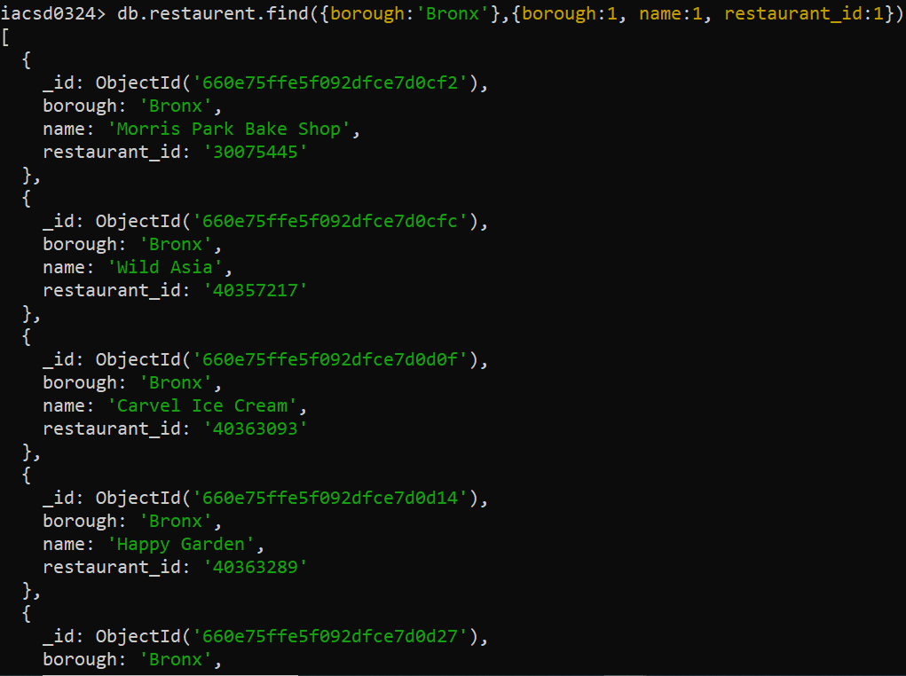

**6. Write a MongoDB query to display the first 5 restaurant which is in the borough Bronx.**

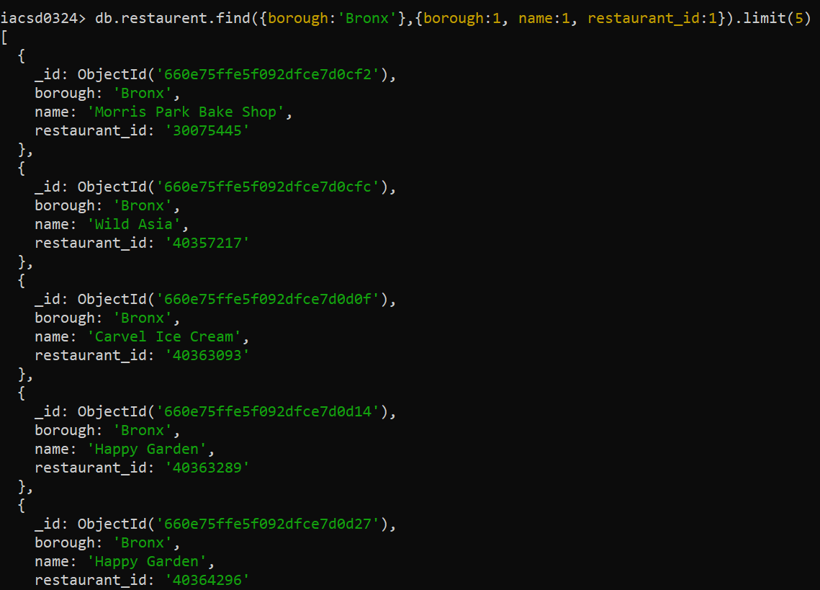

**7.Write a MongoDB query to display the next 5 restaurants after skipping first 5 which are in**

**the borough Bronx.**

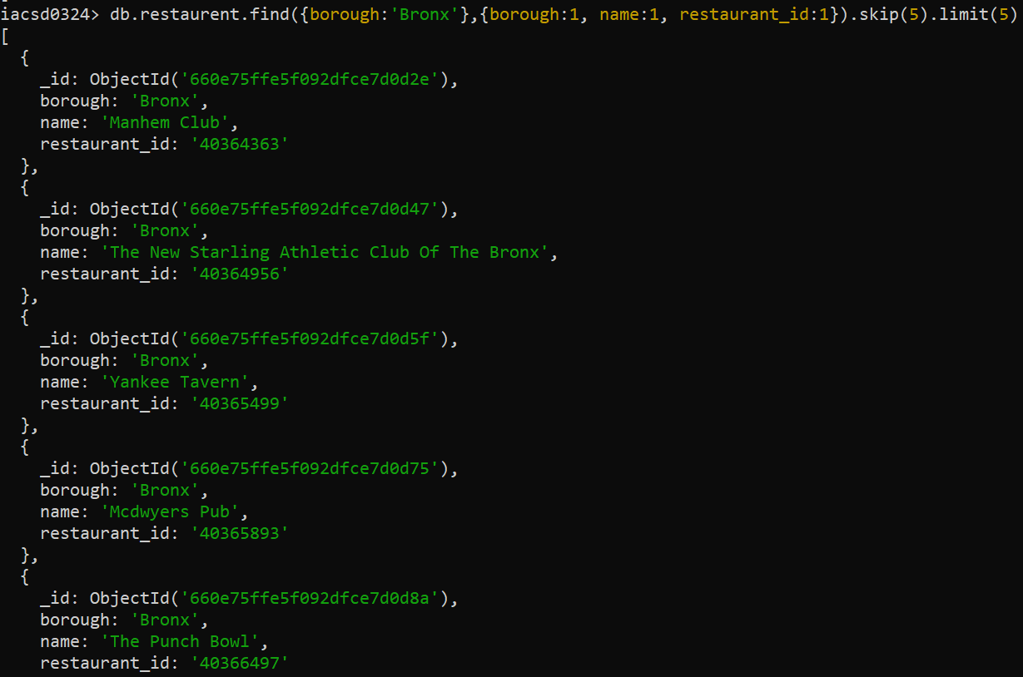

**8. Write a MongoDB query to find the restaurants who achieved a score more than 90.**

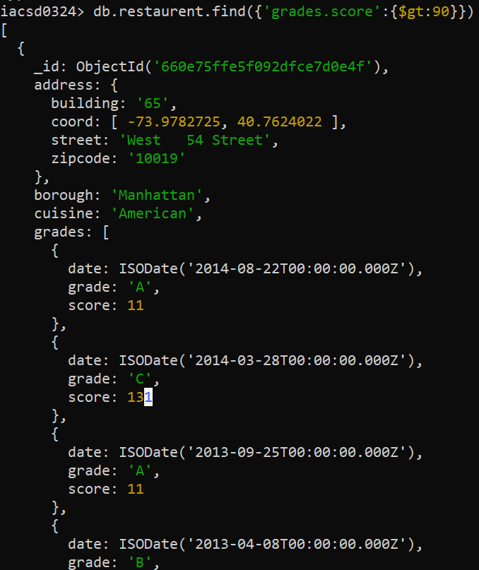

**9. Write a MongoDB query to find the restaurants that achieved a score, more than 80 but**

**less than 100.**

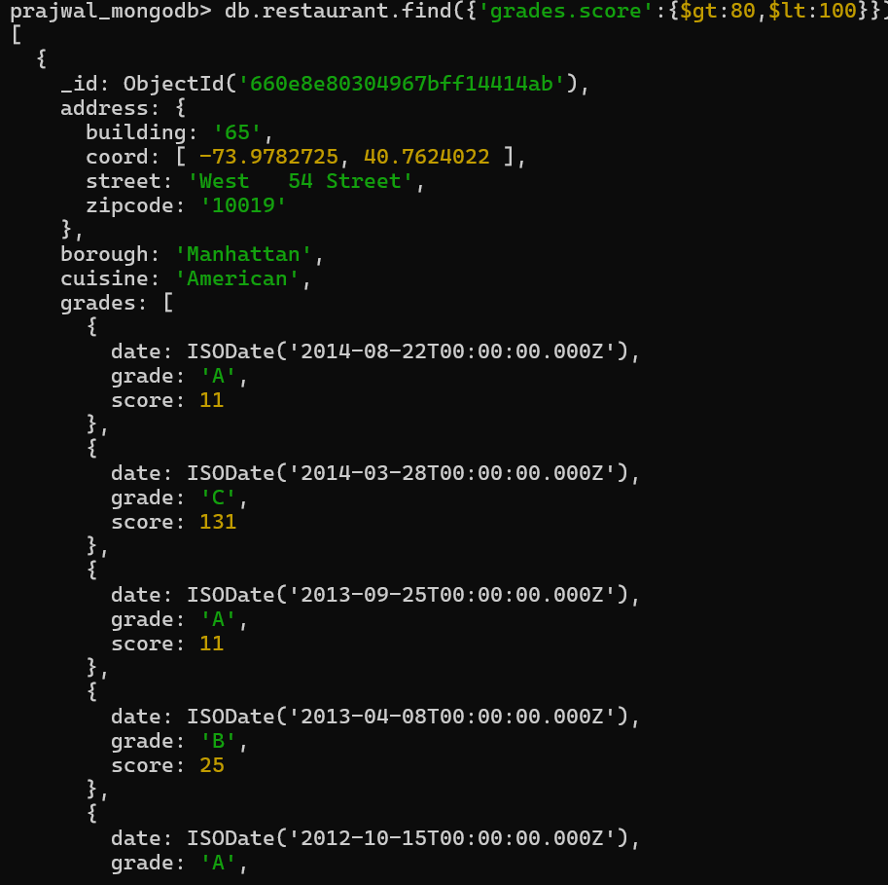

**10. Write a MongoDB query to find the restaurants which locate in latitude value less than -**

**95.754168.**

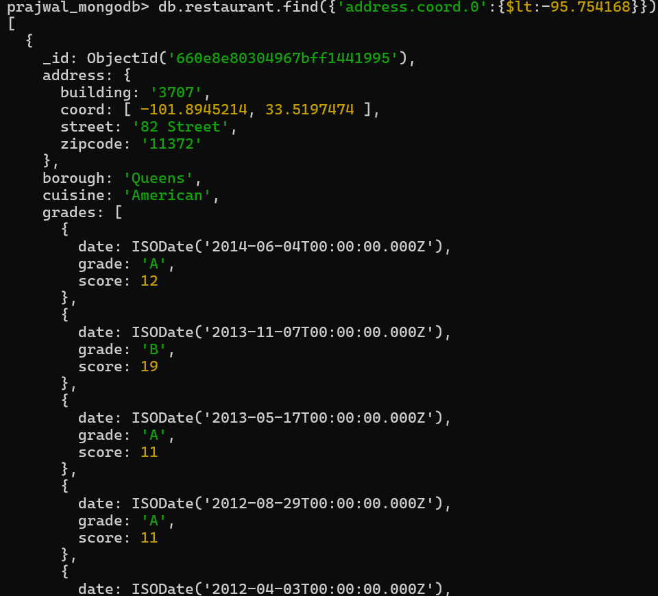

**11. Write a MongoDB query to find the restaurants that do not prepare any cuisine of**

**'American' and their grade score more than 70 and latitude less than -65.754168.**

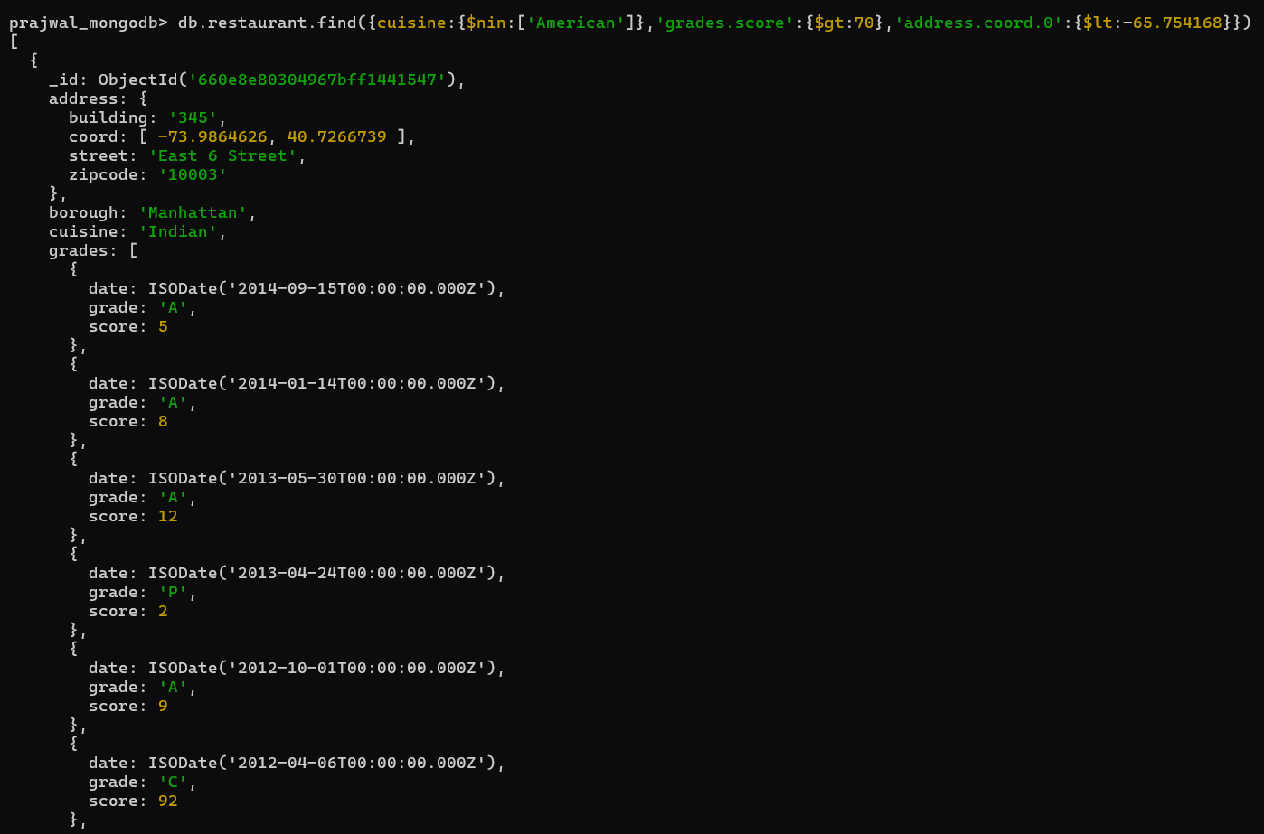

**12. Write a MongoDB query to find the restaurants which do not prepare any cuisine of**

**'American' and achieved a score more than 70 and located in the longitude less than -**

**65.754168.**

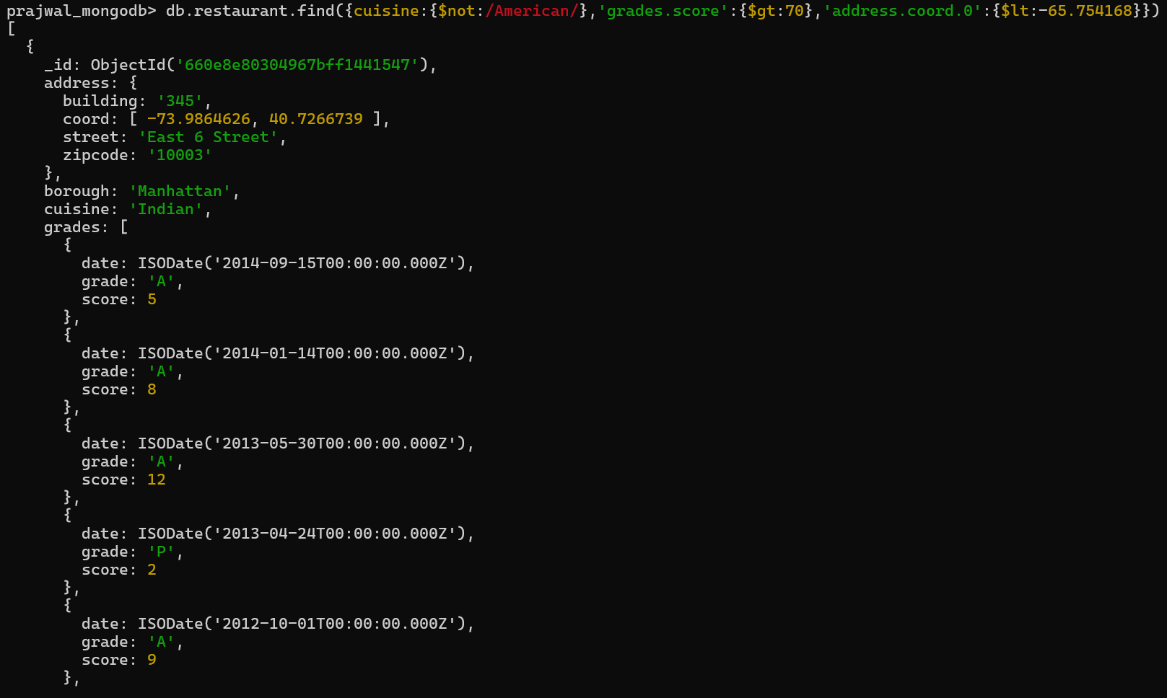

**13. Write a MongoDB query to find the restaurants which do not prepare any cuisine of**

**'American ' and achieved a grade point 'A' not belongs to the borough Brooklyn. The**

**document must be displayed according to the cuisine in descending order.**

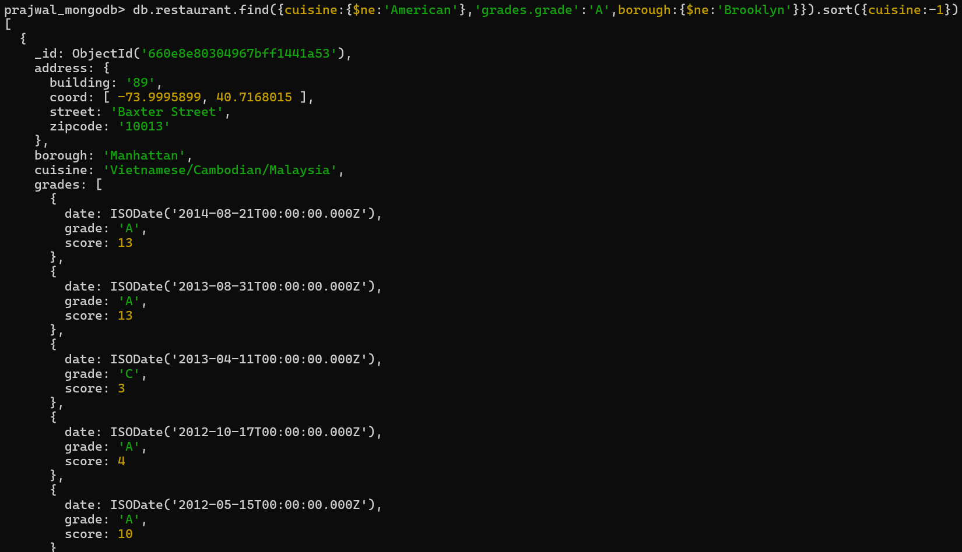

**14. Write a MongoDB query to find the restaurant Id, name, borough and cuisine for those**

**restaurants which contain 'Wil' as first three letters for its name.**

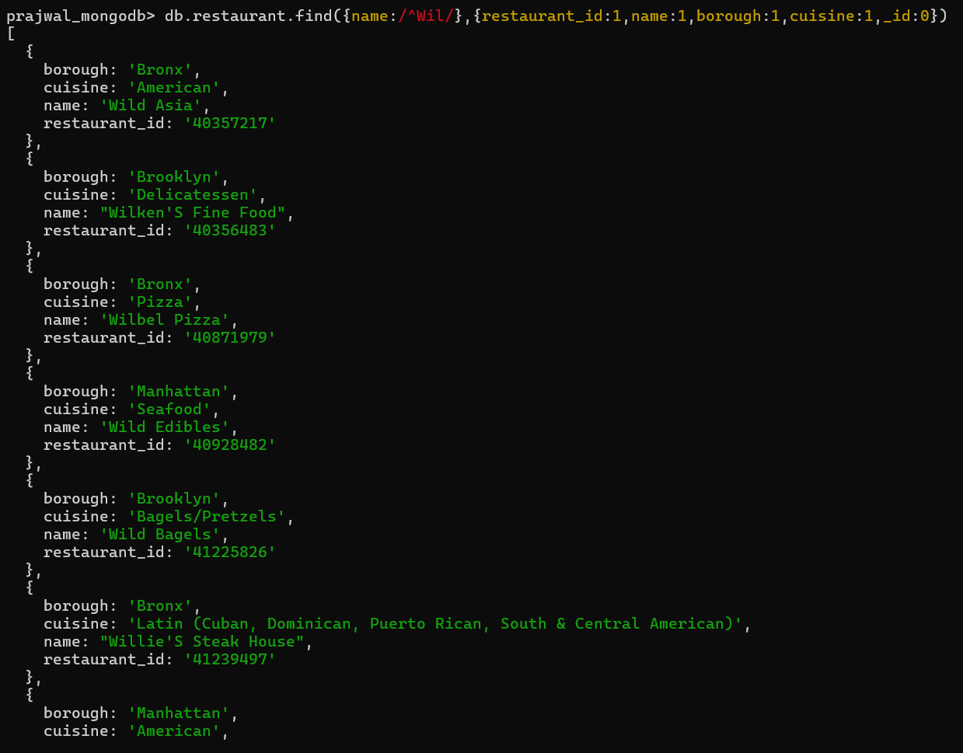

**15. Write a MongoDB query to find the restaurant Id, name, borough and cuisine for those**

**restaurants which contain 'ces' as last three letters for its name.**

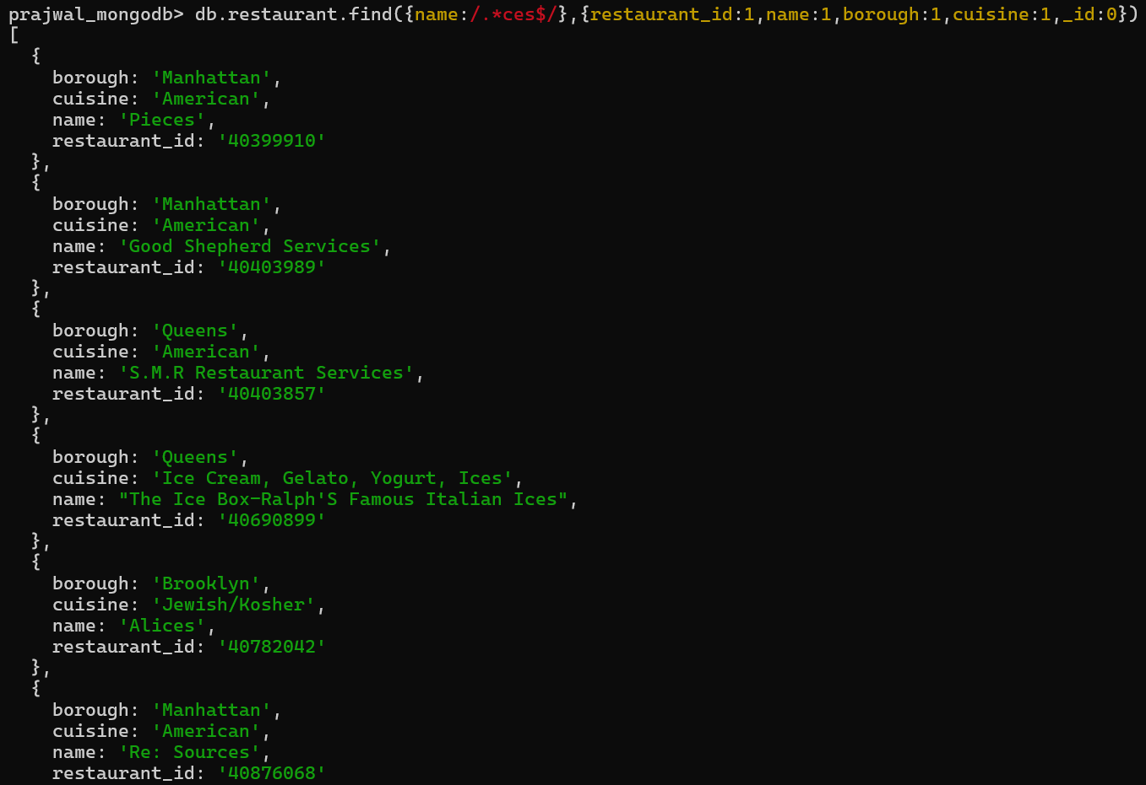

**16. Write a MongoDB query to find the restaurant Id, name, borough and cuisine for those**

**restaurants which contain 'Reg' as three letters somewhere in its name.**

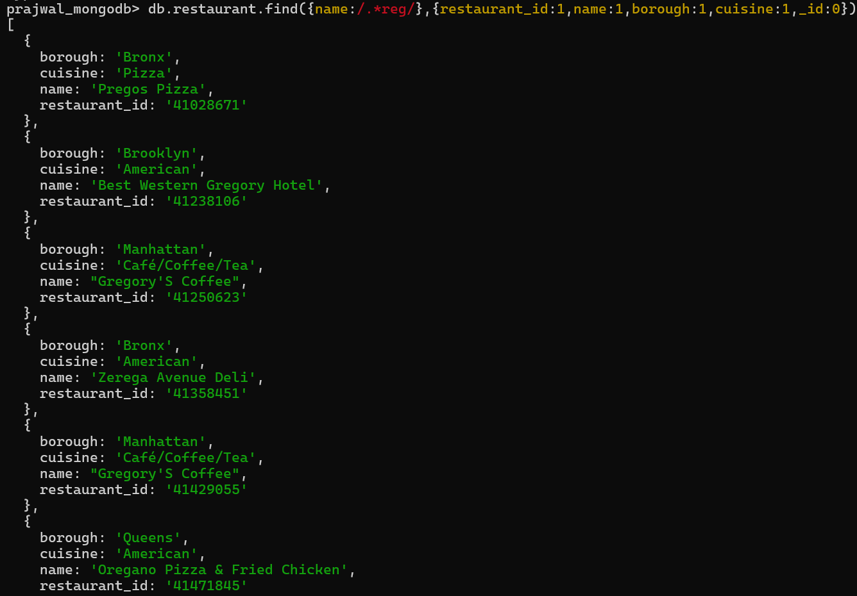

**17. Write a MongoDB query to find the restaurants which belong to the borough Bronx and**

**prepared either American or Chinese dish.**

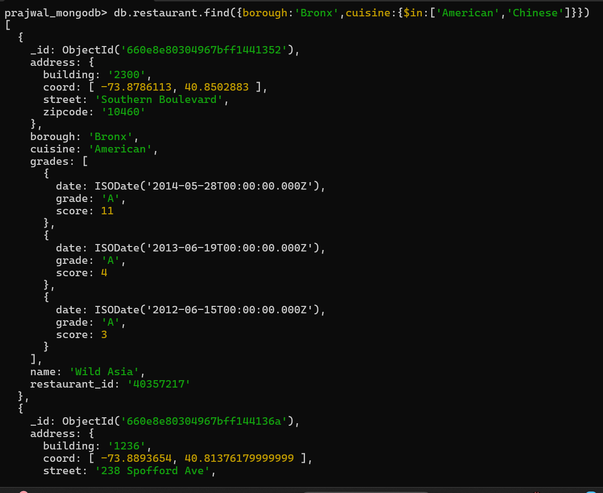

**18. Write a MongoDB query to find the restaurant Id, name, borough and cuisine for those**

**restaurants which belong to the borough Staten Island or Queens or Bronxor Brooklyn.**

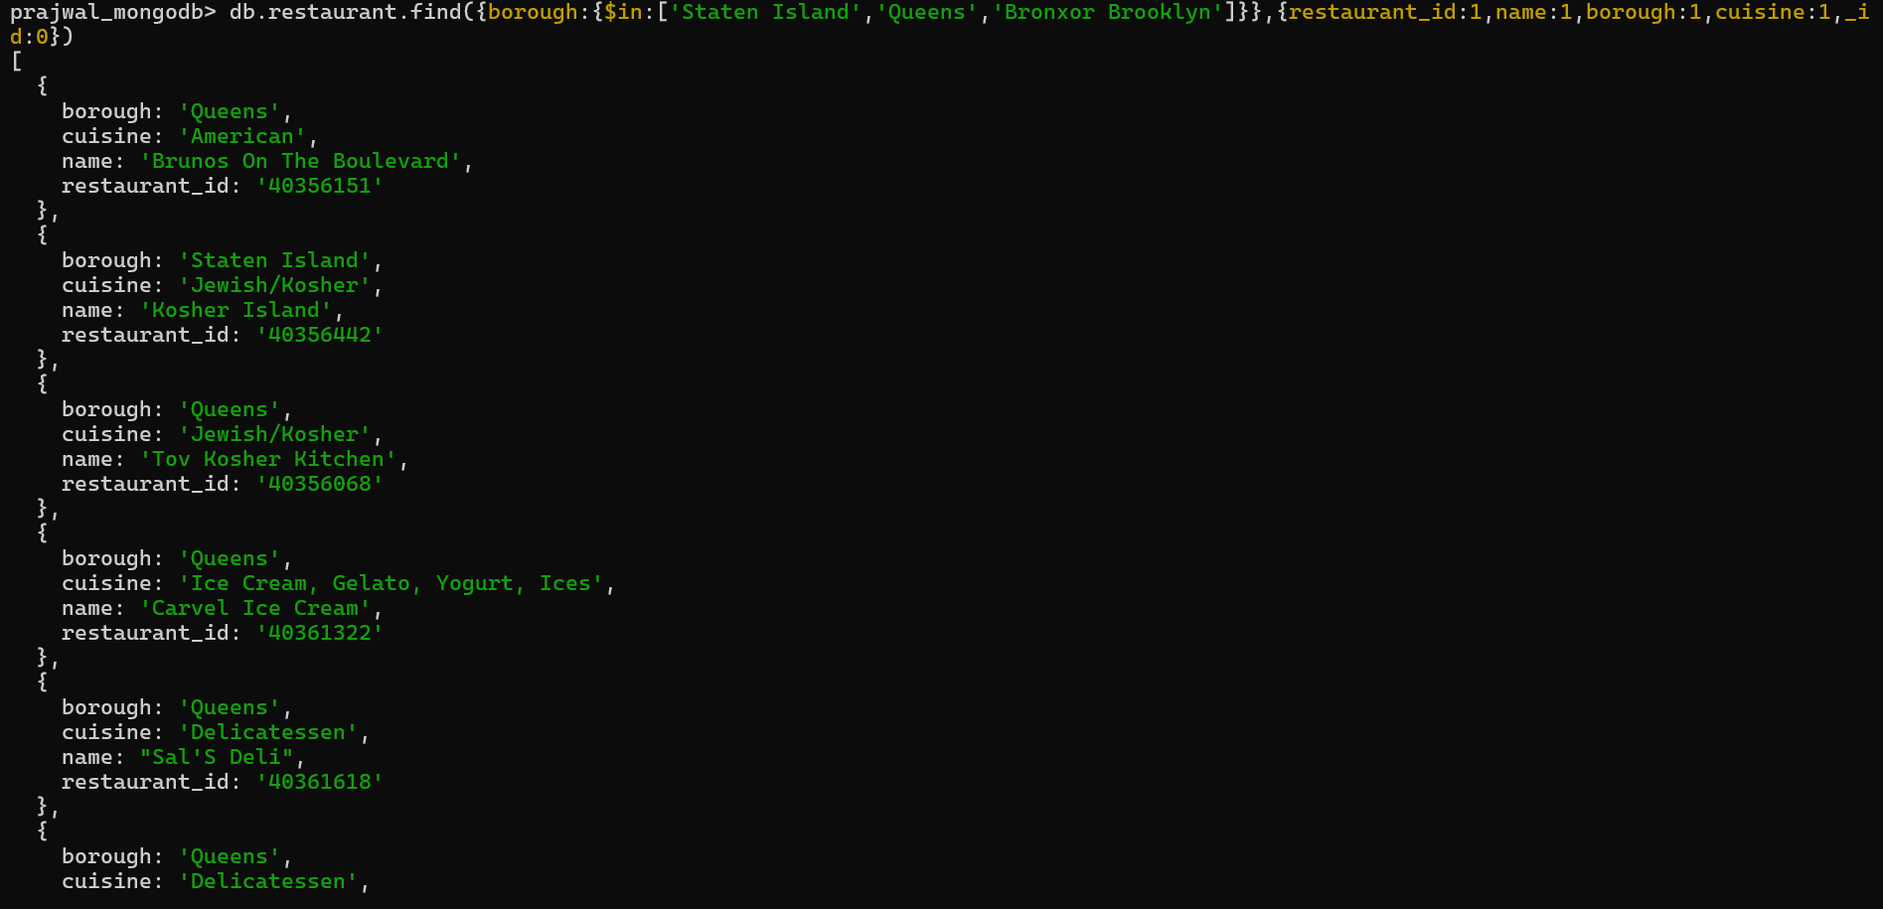

**19. Write a MongoDB query to find the restaurant Id, name, borough and cuisine for those**

**restaurants which are not belonging to the borough Staten Island or Queens or Bronxor**

**Brooklyn.**

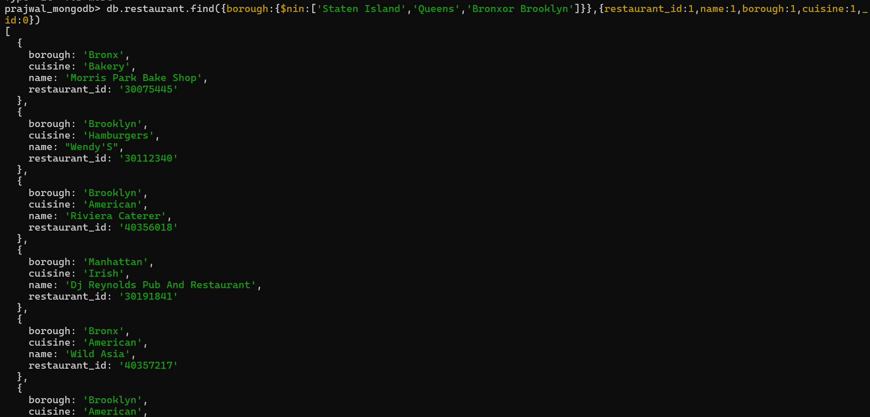

**20. Write a MongoDB query to find the restaurant Id, name, borough and cuisine for those**

**restaurants which achieved a score which is not more than 10.**

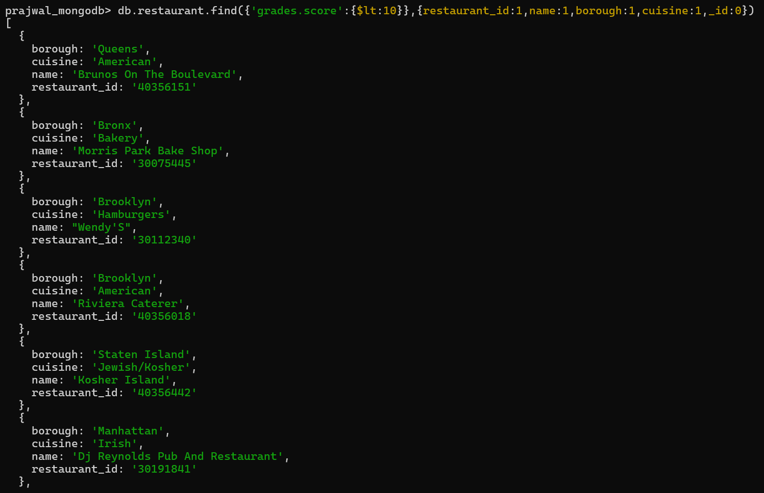

**21. Write a MongoDB query to find the restaurant Id, name, borough and cuisine for those**

**restaurants which prepared dish except 'American' and 'Chinees' or restaurant's name begins**

**with letter 'Wil'.**

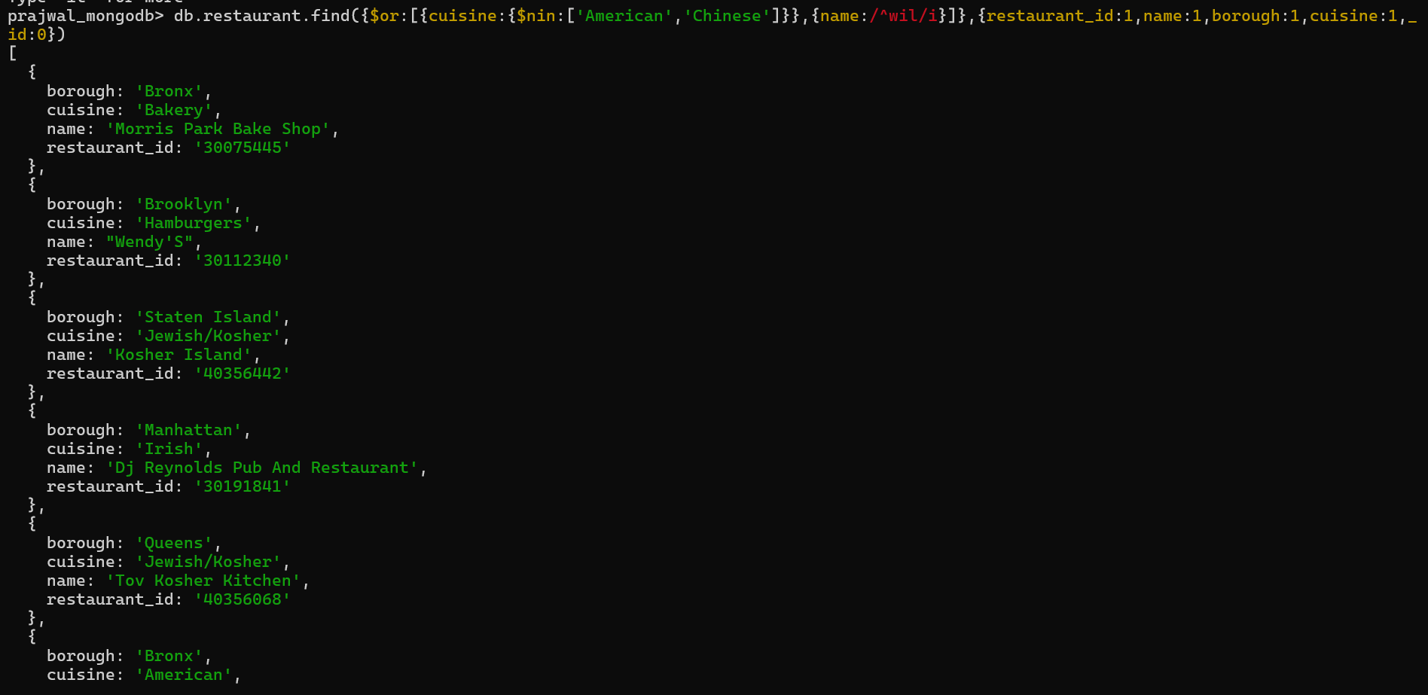

**22. Write a MongoDB query to find the restaurant Id, name, and grades for those restaurants**

**which achieved a grade of "A" and scored 11 on an ISODate "2014-08-11T00:00:00Z"**

**among many of survey dates**

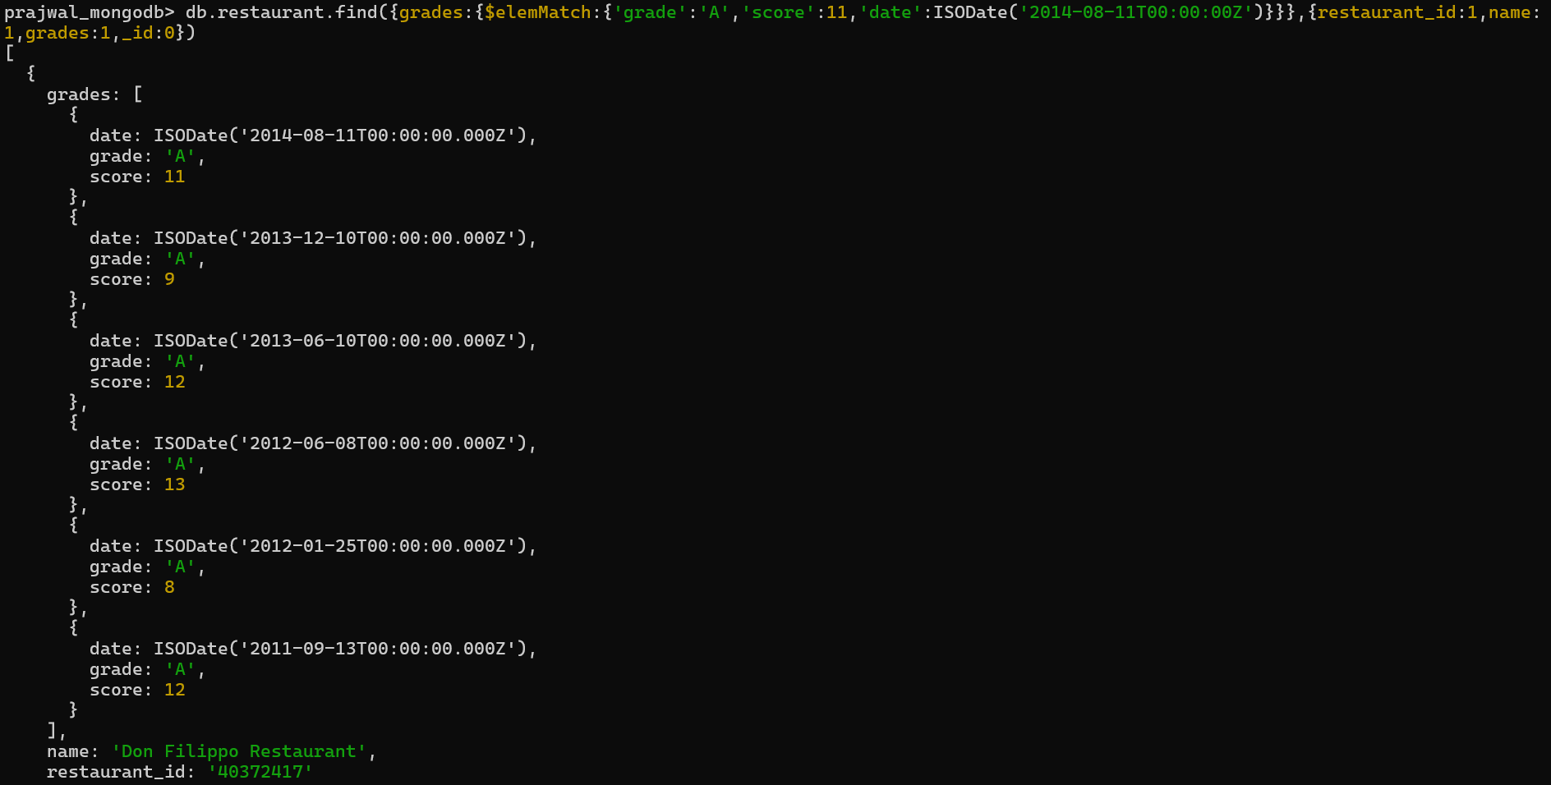

**23. Write a MongoDB query to find the restaurant Id, name and grades for those restaurants**

**where the 2nd element of grades array contains a grade of "A" and score 9 on an ISODate**

**"2014-08-11T00:00:00Z".**

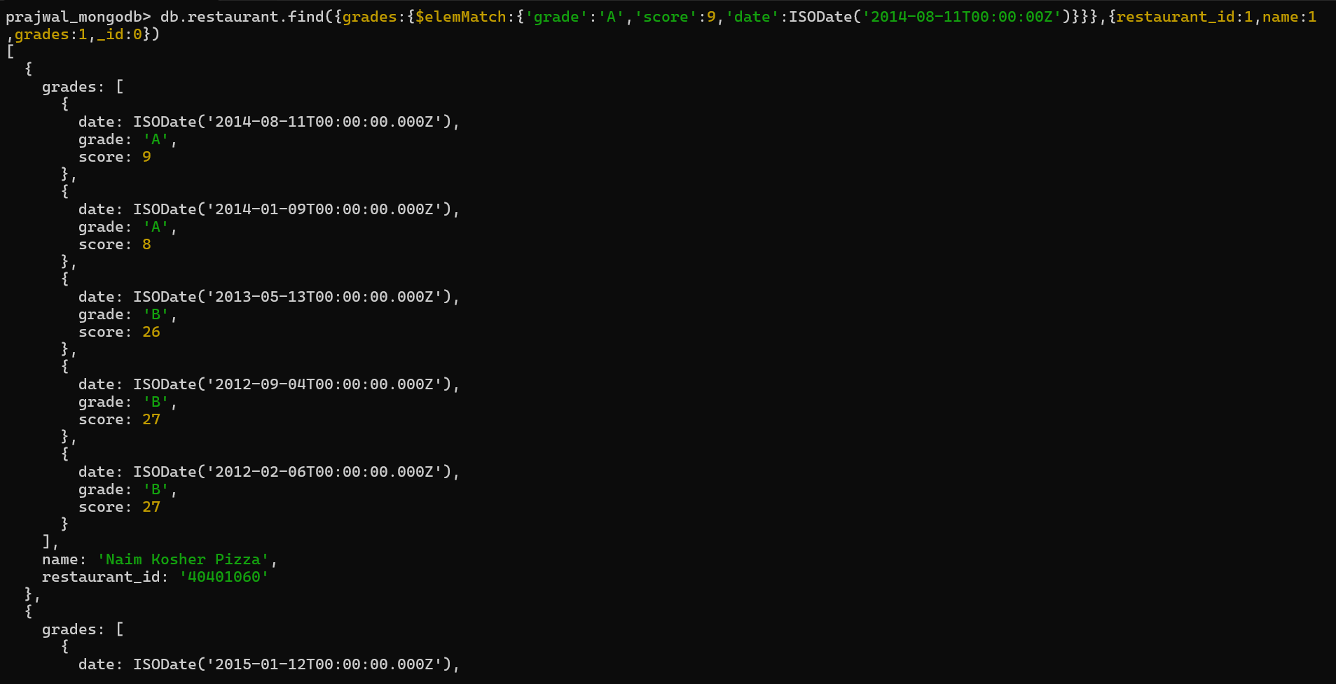

**24. Write a MongoDB query to find the restaurant Id, name, address and geographical**

**location for those restaurants where 2nd element of coord array contains a value which is**

**more than 42 and upto 52**

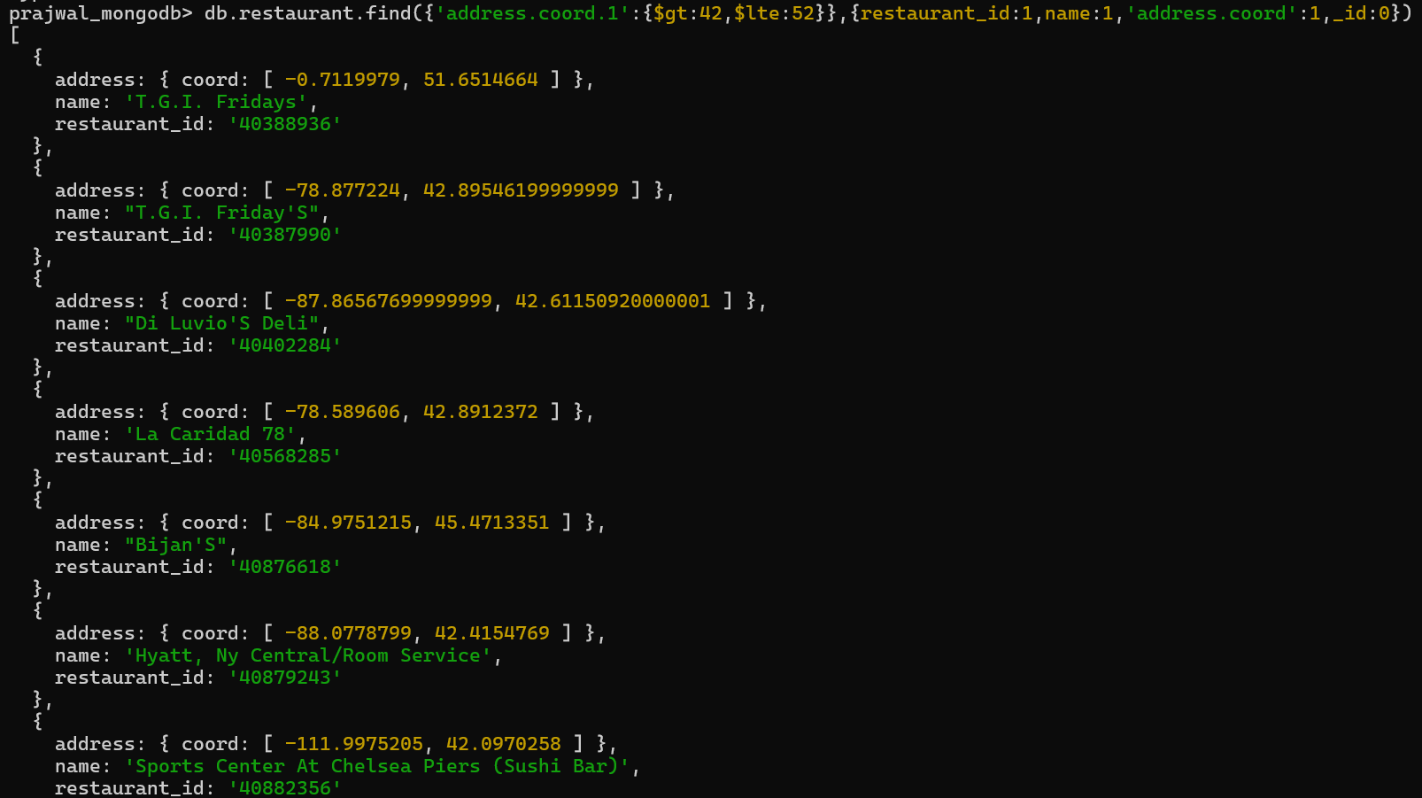

**25. Write a MongoDB query to arrange the name of the restaurants in ascending order along**

**with all the columns.**

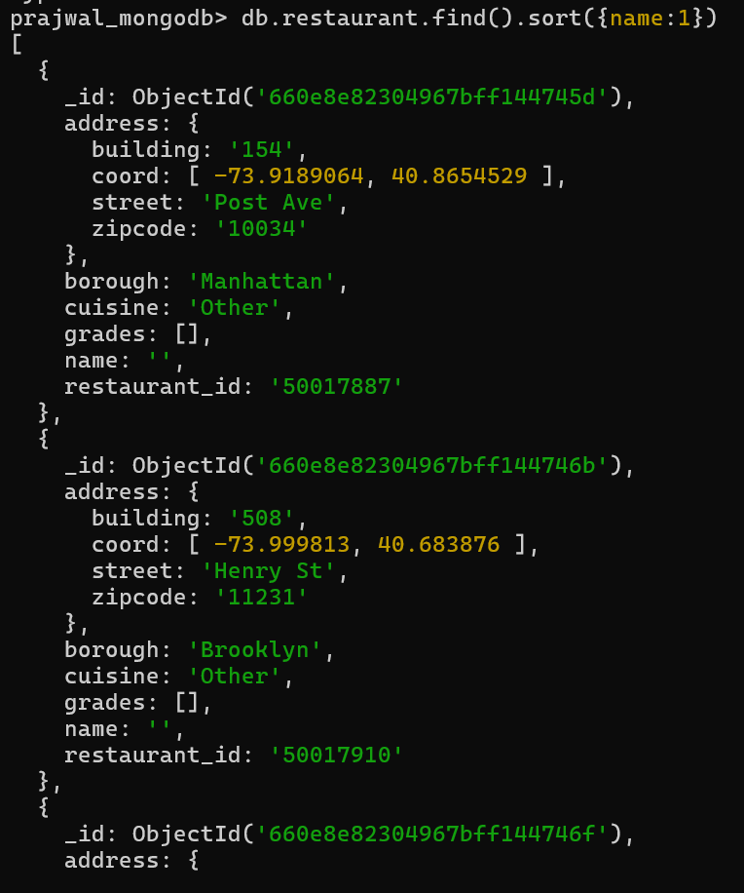

**26. Write a MongoDB query to arrange the name of the restaurants in descending along with**

**all the columns.**

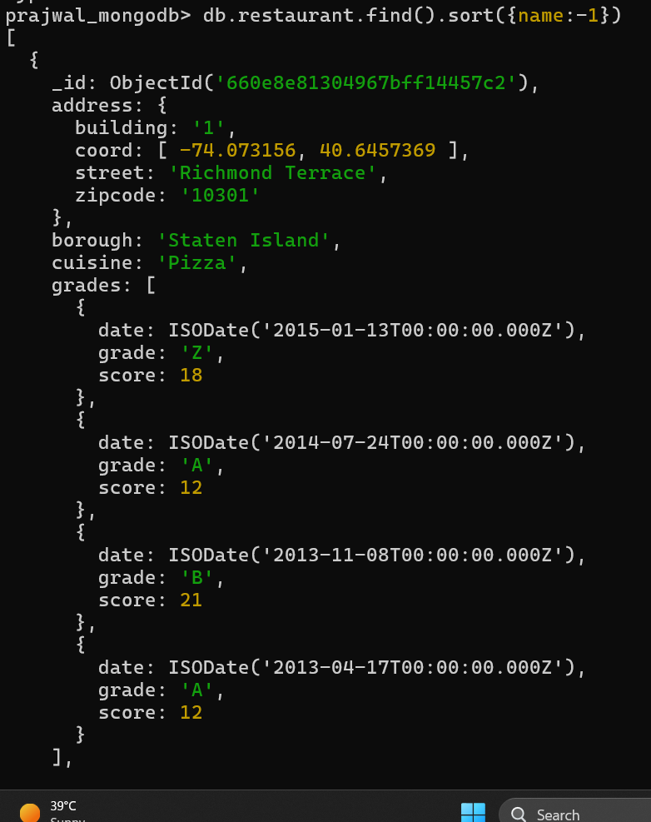

**27. Write a MongoDB query to arranged the name of the cuisine in ascending order and for**

**that same cuisine borough should be in descending order.**

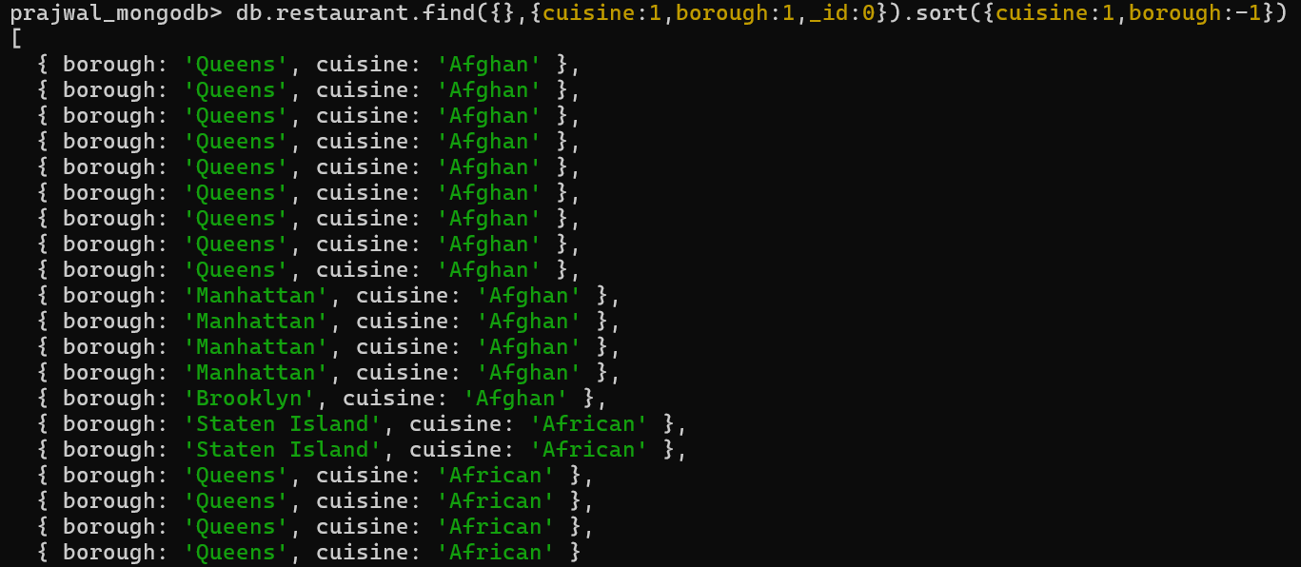

**28. Write a MongoDB query to know whether all the addresses contains the street or not.**

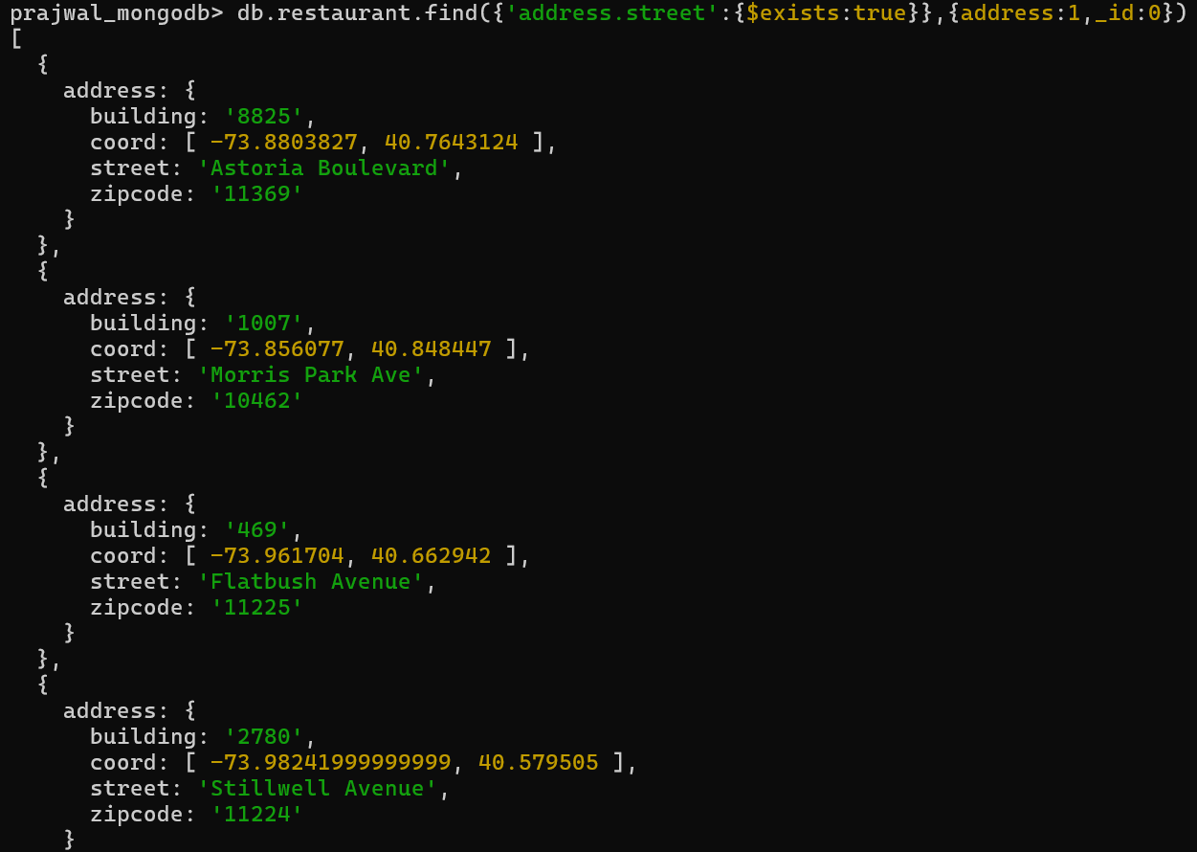

**29. Write a MongoDB query which will select all documents in the restaurants collection**

**where the coord field value is Double.**

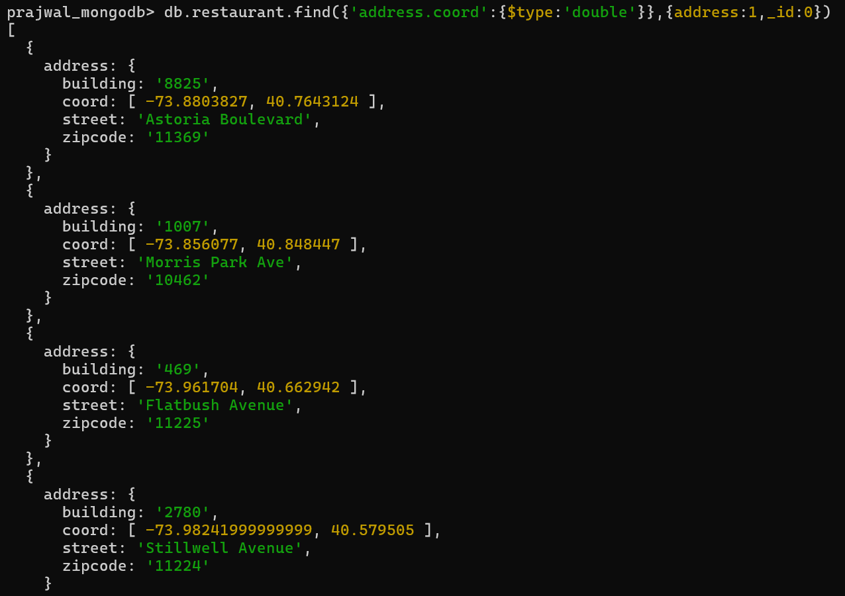

**30. Write a MongoDB query which will select the restaurant Id, name and grades for those**

**restaurants which returns 0 as a remainder after dividing the score by 7.**

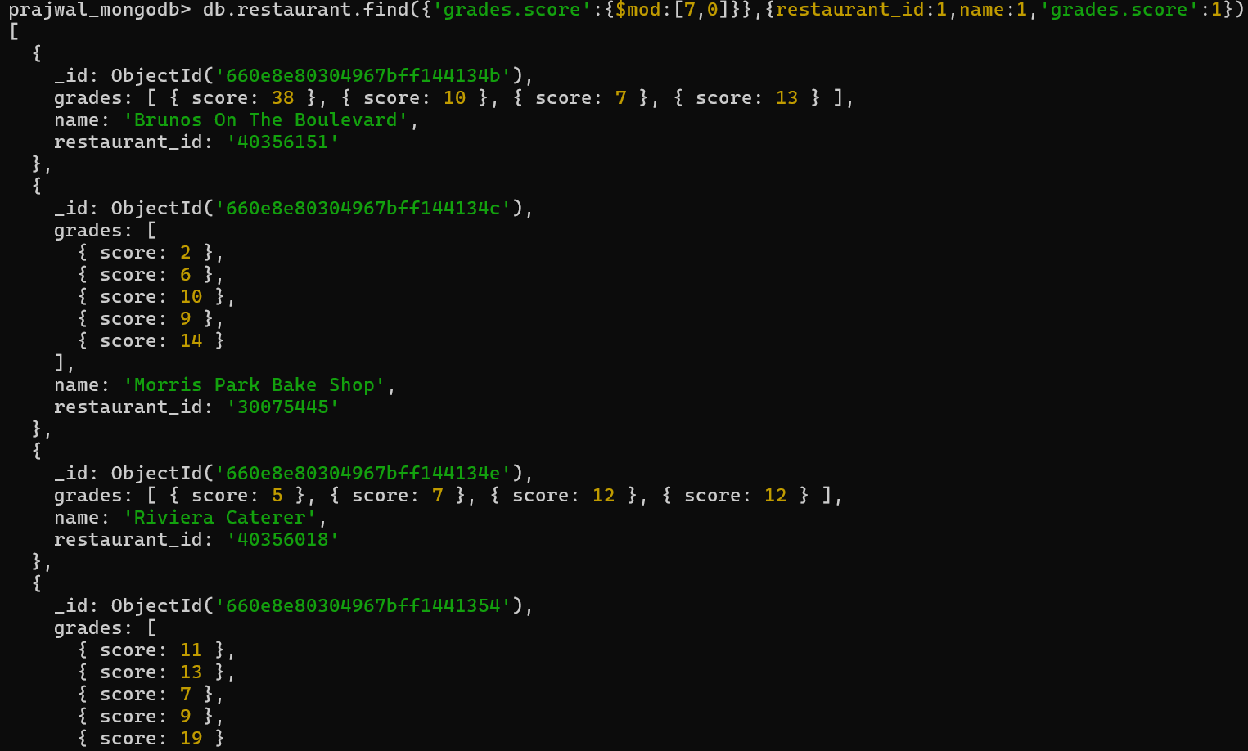

**31. Write a MongoDB query to find the restaurant name, borough, longitude and attitude and**

**cuisine for those restaurants which contains 'mon' as three letters somewhere in its name.**

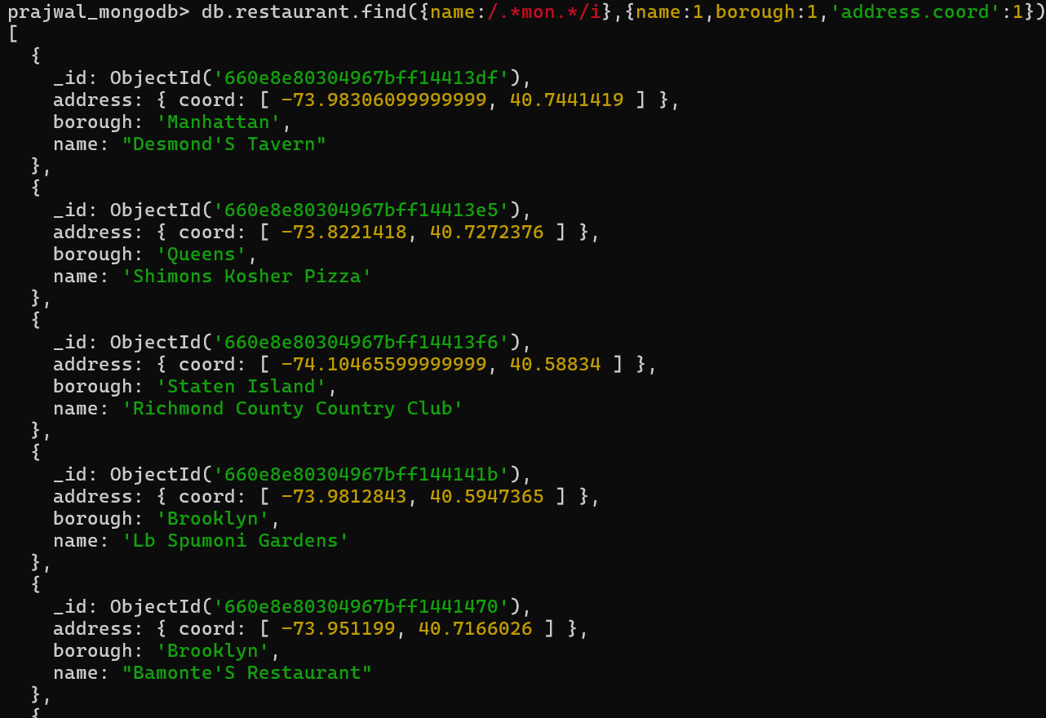

**32. Write a MongoDB query to find the restaurant name, borough, longitude and latitude and**

**cuisine for those restaurants which contain 'Mad' as first three letters of its name.**

